BANK LOAN - SQL QUERIES

Total Loan Applications





MTD Loan Applications

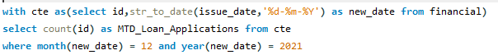



PMTD Loan Applications

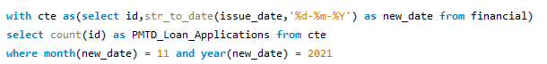



Total Funded Amount





MTD Funded Amount





PMTD Funded Amount





Total Amount Received





MTD Amount Received





PMTD Amount Received





Average Interest Rate





MTD Average Interest Rate





PMTD Average Interest Rate

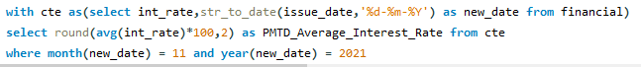



Average DTI





MTD Average DTI

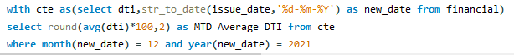



PMTD Average DTI





Good_Loan_Percentage





Good_Loan_Applications





Good_Loan_Funded Amount





Good_Loan_Amount Received





Bad_Loan_Percentage





Bad_Loan_Applications





Bad Loan_Funded Amount





Bad Loan Amount Received





Loan Status

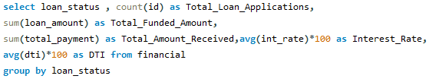

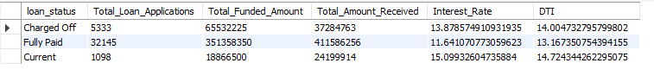



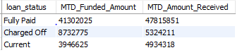

Monthly trends by issue date

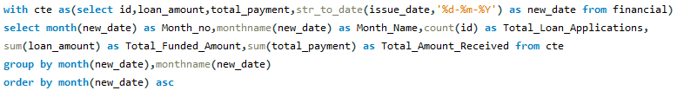

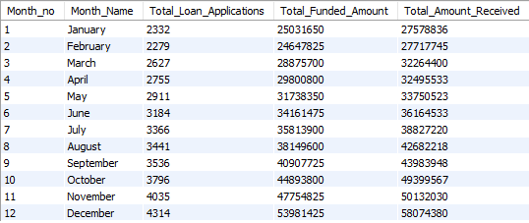

Trends by Address State

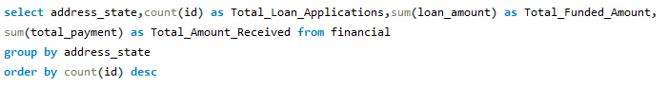

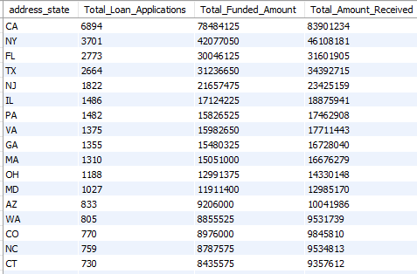

Trends by Employee Length

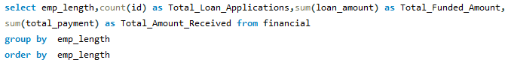

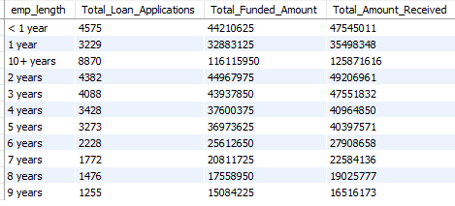

Trends by Purpose

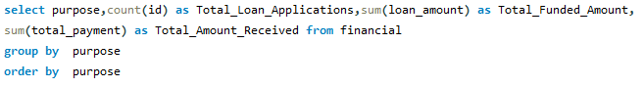

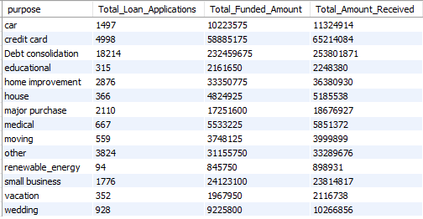

Trends by Home Ownership

